Term 1 | Term 2 | Term 3 | Term 4 | Term 5 | Term 6
The Snail and the Whale  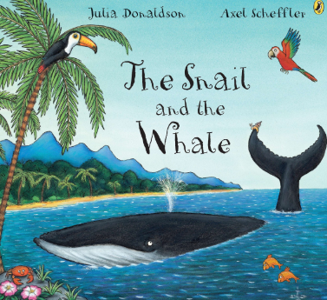  by Julia Donaldson  Lila and the Secret of Rain  by David Conway and Jude Daly  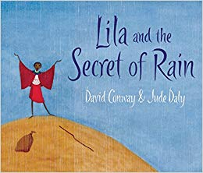  The Colour Monster  By Anna LLenas  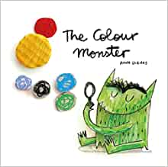 | Traction Man is Here  by Mini Grey  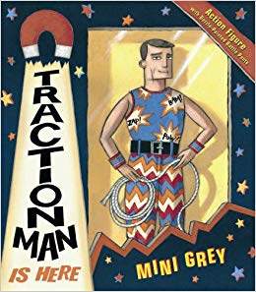  The Tunnel  By Anthony Browne  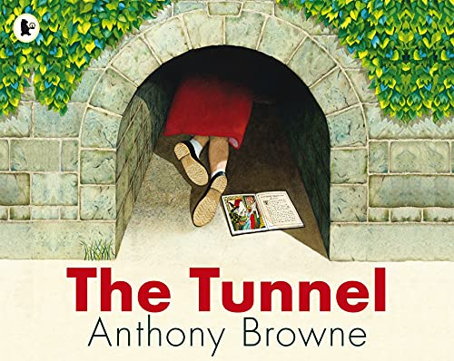 | Toby and the Great Fire of London  by Margaret Nash and Jane Cope  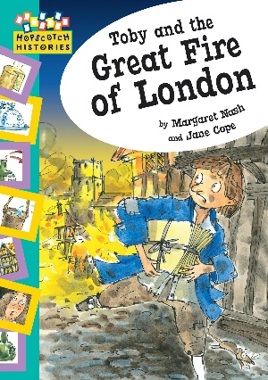  The Secret Sky Garden  Linda Sarah & Fiona Lumbers  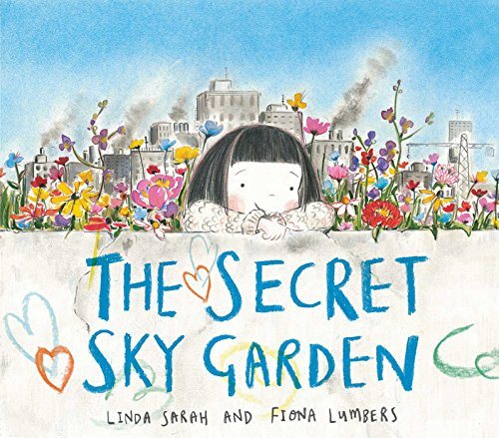 | Traditional Tales  Into the Forest  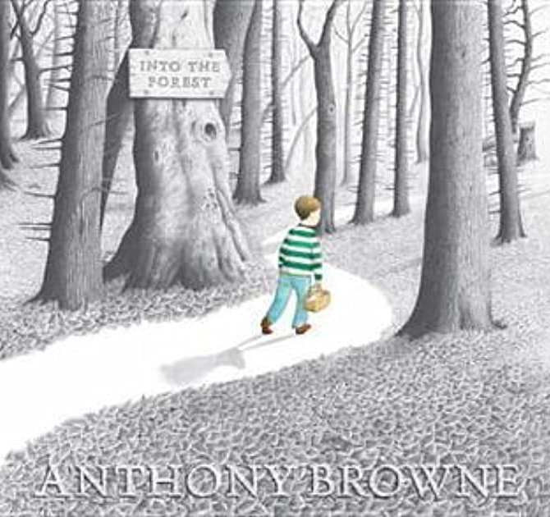  by Anthony Browne  Jim and the Beanstalk  By Raymond Briggs  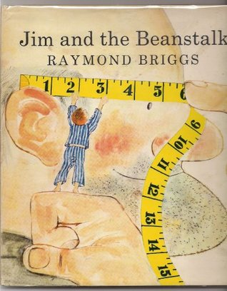 | The Titanic for Kids  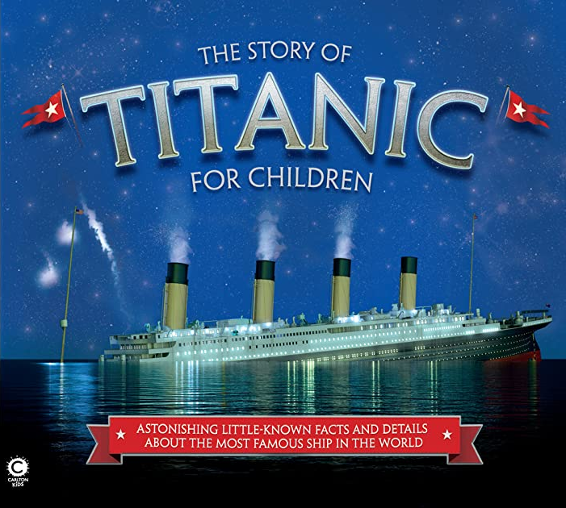  by Joe Fullman  I was There - On Board the Titanic  By Margi McAllister  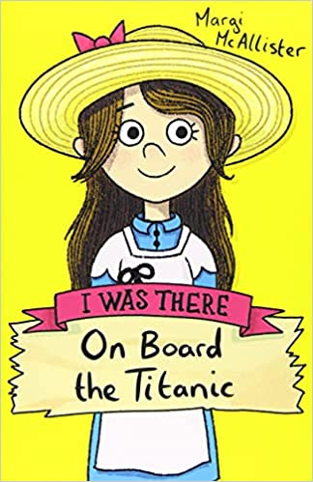  Little Red  by Lynn Roberts  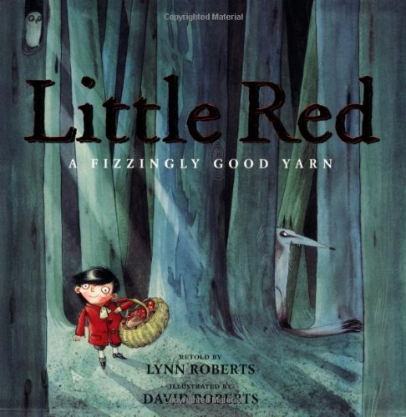 | The Magic Finger  by Roald Dahl  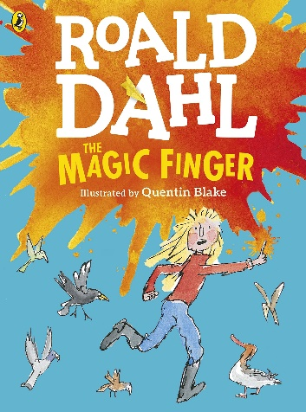  Young, Gifted and Black  By Jamia Wilson  