**Kids! Did you know…**

Eating a sustainable diet is so important for the future of our planet - it reduces our carbon footprint and is more environmentally friendly. By adjusting where our protein comes from as well as reducing the amount of meat we eat, a more sustainable diet can be achieved.

Contrary to many opinions, reducing meat protein and increased plant-based protein does not reduce the quality of the diet (or the protein!). In fact, by increasing consumption of plant-based proteins, we get additional benefits such as increased fibre intake!

KS2 – Factsheet

**SUSTAINABLE EATING –**

**WHAT FOODS ARE BETTER FOR THE PLANET?**

- - - - - - - - - - - - - - - - - - - - - - - - - - - - - - - - - - - - - - - - - - - - - - - - - - - - - - - - - - - - - - - - - - - - - - - - - - - - - - - - - - - - - - - - - - - - - -

4. At Caterlink we use lentils within our recipes, to create more earth friendly dishes. Can you find your way to the Lentils?

**CHICKPEA PLANT**

**How many different ‘Added Plant Power’ dishes have you eaten this week?**

**Our Added Plant Power dishes are marked with an Earth logo!**

**ACTIVITY**

- - - - - - - - - - - - - - - - - - - - - - - - - - - - - - - - - - - - - - - - - - - - - - -

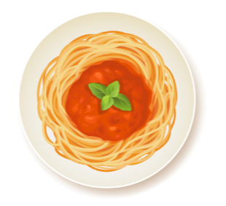

**AT HOME:**

**Did you know…** At Caterlink, we are proud to have altered many of our meat-based dishes to be more environmentally friendly, by adding 50% plant protein. We call these our ‘Added Plant Power’ recipes and are highly popular. We use meat that is locally sourced, further minimising environmental impact and supporting local economies!

- - - - - - - - - - - - - - - - - - - - - - - - - - - - - - - - - - - - - - - - - - - - - - -

Try using 50% lentils and 50% meat to homecooked dishes, such as bolognaise, cottage pie and lasagne. Or try a variety of different canned beans (chickpeas, kidney beans, butterbeans) in a vegetable stew!

v